Best Practice 1.
Title of the Practice:Students' Week
Objectives Of The Practice:
Regarding the objectives of the practice, the primary objective was to develop in the students an all round awareness of the duties and responsibilities as important stakeholders of institution. Its object was also to provide students adequate awareness of the world around them, to empower them with knowledge so as to make a Holistic development which will run parallel to their academic pursuits. The object is also to develop them into good citizens for the future of the country and make them aware of the opportunities that lay before them both inside and outside the present educational pursuit.
The Context:
After a long period of lockdown and college closure, it was important on the part of the college to return to its everyday activities both in its curricular and co curricular dimensions. The long discontinuation in normal classes has rendered a section of the students wayward and proper restoration of the day today activities of the college was necessary. Some students quite clearly were at a loss of how to restart their everyday regular academic life and needed a bit of counselling both from the vocational and the psychological points of view. The spirit of competitiveness and camaraderie is best brought in by different competitions. Farther, these competitions also aid the institution in the process of Talent Hunt. There has been many students whose individual talents have come into notice and who has been patronized through such competitive meets. Keeping this in view the students’ week was mainly organised to focus on counselling of both vocational and psychological sort, and some cultural competitions to be held among the students. Introducing the students and the other stakeholders of the HEI to various schemes offered by the government for them was also an important purpose behind the awareness programmes held in the Students’ Week. It was also necessary for the students to be acquainted with the various possibilities that digital education as well as the digital library system opened for them. Awareness programmes related to these were also organised.
The Practice
0n the New Year's Day the series of programmes celebrating Students' Week was opened with an International Webinar on Career Counselling organised by the departments of History and Bengali of the college in collaboration with the Internal Quality Assessment Cell. The speakers were Marjan Adeli, Software Developer, Cloud Infrastructure, Google. and. Souti Chattopadhyay, Oregon State University, USA where they enlightened the students on different aspects of choice of future career open before them. The international seminar also hosted a very lively interactive session between the resource persons and the stakeholders.
On 02/01/2022 an Online State Level Webinar was held on the topic ‘Digital Education - The Changing Horizon’. It was jointly organised by the Departments of Arabic and the IQAC of the college. The speakers were Dr Chaiti Mitra, Associate Professor Of The Department of English, Ramakrishna Sarada Mission Vivekananda Vidyabhavan and Dr Rafiqul Alam, Librarian, Malda College. The webinar successfully acquainted the students as well as the faculty on the various aspects of digital education along with the use of the Digital Library.
On 03/1/2022 an Online Psychological Session was held jointly organised by the lQAC, English and Sanskrit Departments of the college. Dr Urmi Chakraborty, Assistant Professor in Psychology, WBES, Government College of Education, Banipur, acted as the resource person. The session was extremely lively with students asking all kinds of questions related to their personal lives and academic pursuits. It gave them the opportunity of venting out their psychological concerns particularly in the postpandemic situation.
On 04/1/2022, the Sociology and the Philosophy Departments of the college organised in collaboration with the IQAC an online talk on the subject of Students Welfare. The talk was delivered by Dr Tushar Kanti Ghara, Joint Director, Education Directorate, Government of West Bengal. In the talk there was a lively discussion on the different facilities and privileges available for the different stakeholders though the particular focus was on the facilities that has been provided by the government for the students like the Kanyashree Project, the different Government and non government scholarships and latest facilities like the Students' Credit Card. the program ended with an extremely interesting question and answer session on these issues.
On 06/01/2023 the Cultural Committee and the lQAC of the college started its series of competitions. 0n this day we had the Vocal Music Competition in the different categories of Rabindra Sangeet, Nazrul Geeti and the songs of the Bengali golden age of music. On 11/01/2022 we had the second set of competitions in a recitation competition jointly organised by the cultural committee, the IQAC and the NSS of the college. The different categories in the competition were the recitation of Poems by Rabindranath Tagore, Nazrul Islam and contemporary Bengali poets. A substantial number of students participated in these competitions. The students week ended with a creative writing competition jointly organised by the Cultural Committee of the college, the NSS and the IQAC. The topics given to the students for this cultural competition were: ‘A Funny Incident that You Have Experienced’, ‘A Rainy Evening’, ‘What Future We Are Facing’ and ‘The Relevance Of Swami Vivekananda in the Present Time’. Students were allowed to write either in English or in Bengali. A substantial number of students took part in the competition. This is how we celebrated the beginning of the Year 2022 in the college with the Students’ Week’.
Evidence of Success
The evidence of success in such awareness programmes is basically long term and therefore difficult to measure at the moment of its completion. Success can be estimated, if not measured from the slow and gradual change that these programmes and competitions cause among the students. The participation and the feedback of all stakeholders in these programmes in fact speaks volumes about their success. The use of digital media and the digital facilities in the college central library has enhanced among the stakeholders, the facilities available are more being availed of. The students’ interest in various competitive and cultural involvements have obviously increased as is evident from they are participation in other competitions that followed the Students’ Week. From the stand point of the college, it seems that we have been successfully able to address and ward off the ennui and the laziness that had engrossed the stakeholders for the long period of the lockdown due to the pandemic crisis.
Problems Encountered and Resources Required
The general problems encountered were all related to the fact that despite having an original intention of conducting most of these programmes offline, we had to actually conduct them online because of the Covid Scare and the temporary closure of the educational institutions through Government Order during this period. Apart from these there was hardly any hindrance and the programmes went in quite a streamlined way. These programmes did not need much resource. Whatever resources were necessary were provided by the college. Had these programmes been offline the pecuniary aspect would have been greater; but because this programmes were online they were conducted with less monetary expenditure. As said above the only limitation was those related to the internet connections which are quite usual in such online programmes. The Google Suite purchased by the college was fully used for the programmes. There have been such awareness programmes and competitions in the college before; but such a long series of programmes will surely leave a lasting mark on the life of the stakeholders in general and the students in particular.

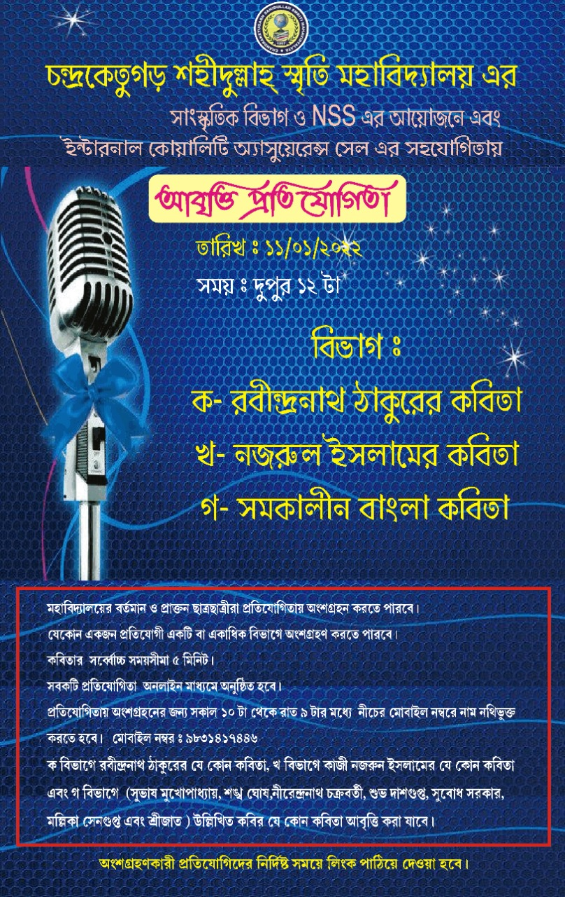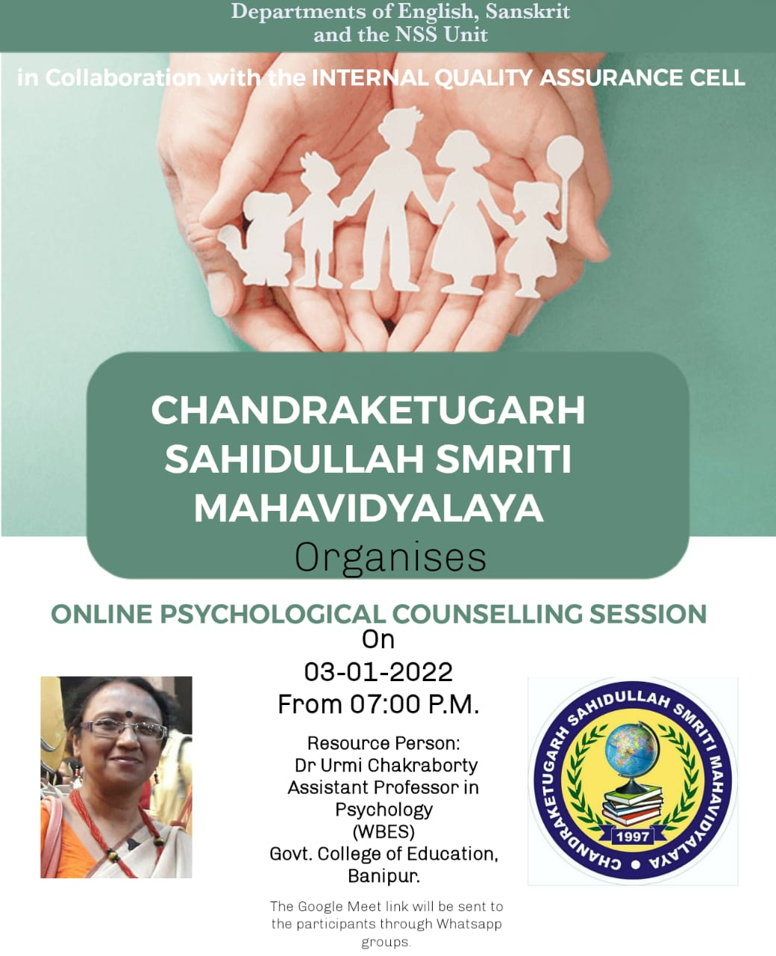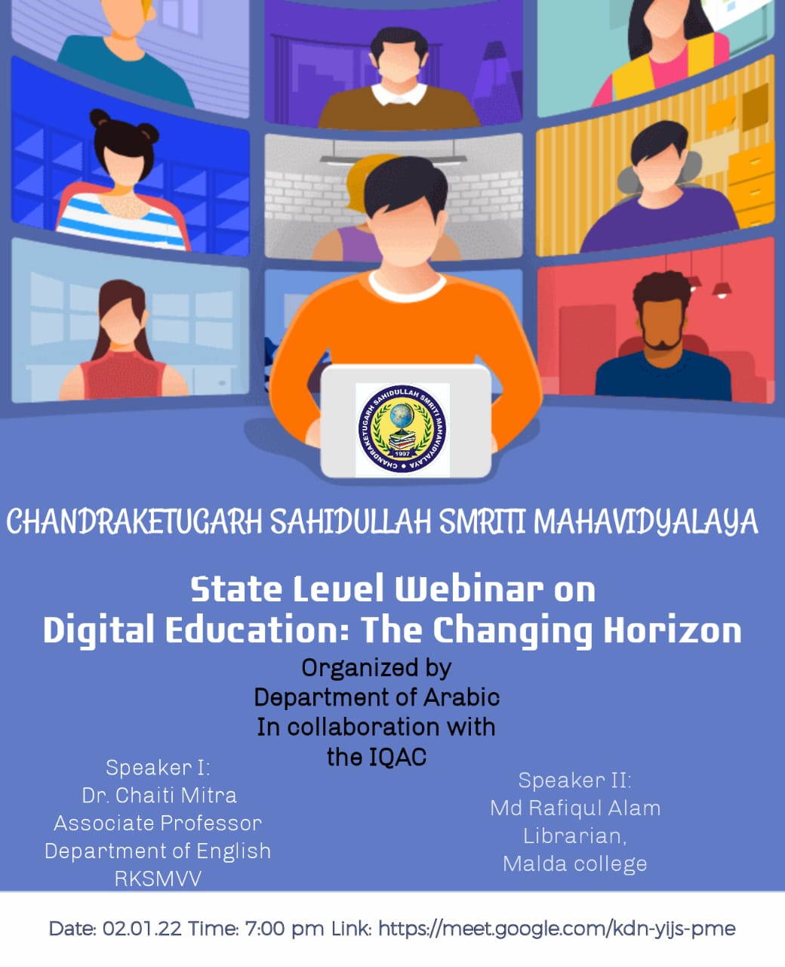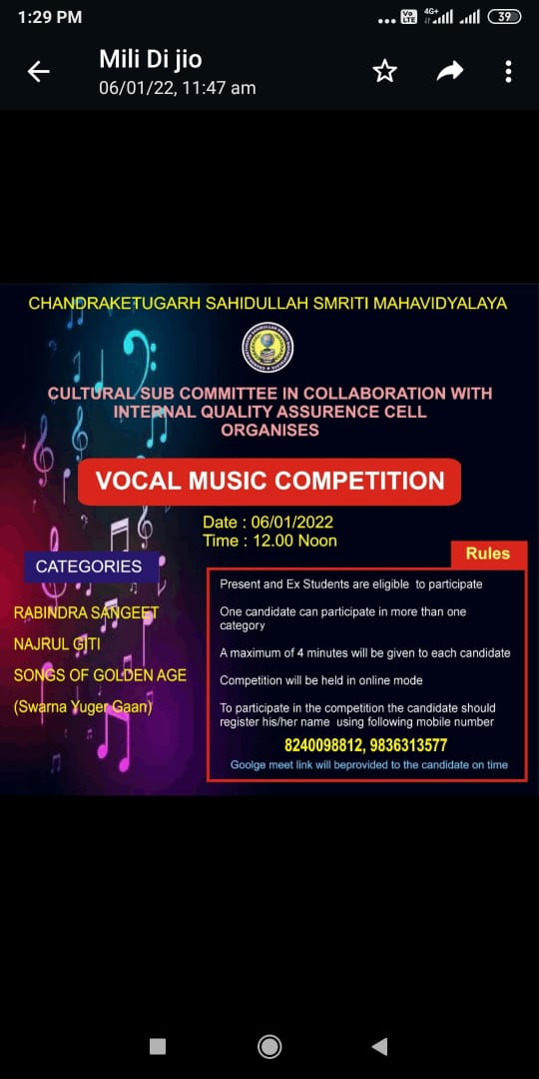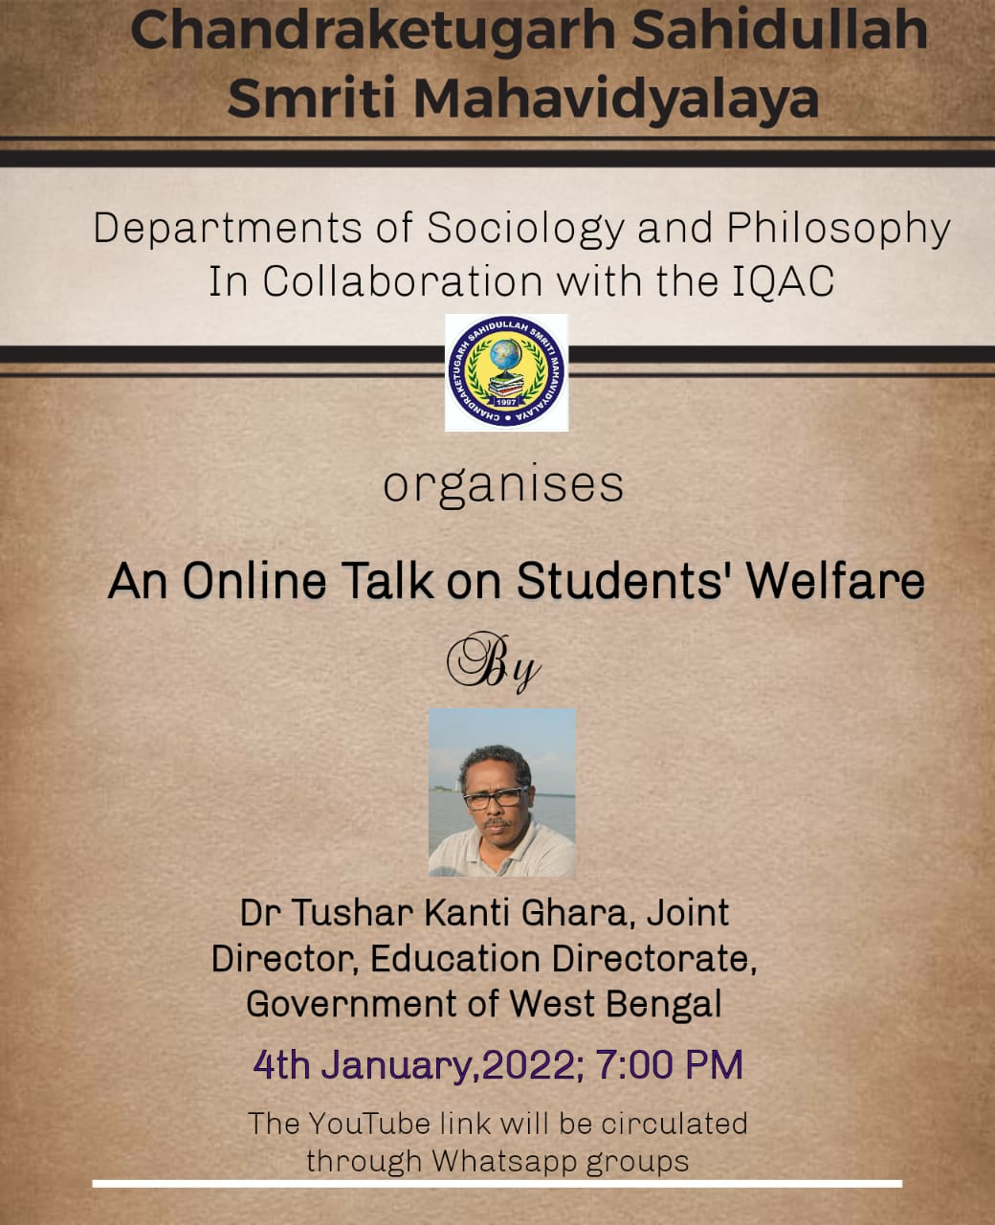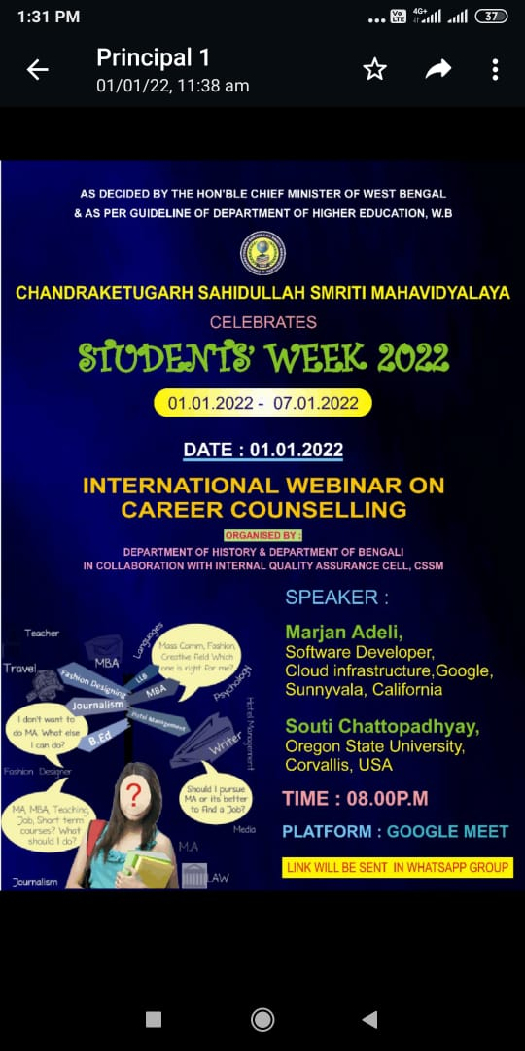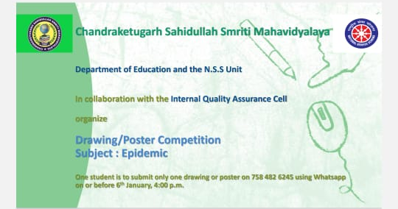
Best Practice 2.
Title of the Practice: Book Exhibition

Objectives of the Practice:
The primary objective was to develop in the students an awareness about the use of books in the teaching learning process and its indispensability. This is particularly important as due to the long spell of college closure on account of the COVID Scare and the subsequent lockdown. Students were become more and more detached with books particularly in physical form and growing more and more reliant dependent on electronic resources. The initiative of organising the book exhibition was taken to bring back the students interest in the books particularly in print and to make the books available to the students both on general topics as well as specific academic subjects and disciplines. Thus, making books available to all stakeholders with particular focus on the students was an important objective of this practice.

The Context:

The two years of college lockdown on account of the Corona Epidemic has caused a disconnect between the students and their primary resources for learning, books and journals. The lockdown has rendered it impossible for many of them to come and secure transactions from the college central library or the departmental libraries or even to personally go to the book shops to avail themselves of books and journals that are necessary for their curricular and extra curricular pursuits. It was also being difficult for the teachers to get hold of books and journals necessary for the teaching learning process during this period. Further, the fact that college is located in a semi rural area with most of its students being first generation students also made it necessary for taking up campaigns that spread the importance of books among the students in particular and the local community in general. It is in this context the book exhibition was held in the college on 25.03.2022.

The practice
It was a one day book Exhibition cum sale program for the students as well as the teachers of our college. The program was started with lighting the candle together by the TIC for the day Dr. Mili Dutta Pal, IQAC co-ordinator Dr. Sourav Bhattacharya and other senior teachers and non-teaching staff of our college. Some book publishers along with some book distributors on different subjects covering all the disciplines in UG level came like Progressive Publishers, Maa sarada Books, Goswami Books etc.
The book collections were mainly on the UG syllabus of the departments of our college. The publishers and book distributors were instructed before hand to bring the books which are mostly relevant to the CBCS syllabus beside the novels, story books, career guidance books. Teachers selected their required books on the respective subjects to purchase for both central and departmental library.

Evidence of success
The collection of books in the exhibition was really very good and helpful for both teachers and students.
There was a spontaneous participation of all the teachers and staff of our college as well as the students from arts and science both disciplines. A good number of books were purchased by our college for the central and departmental libraries. Teachers and students also purchased their required books from the publishers and book distributors. Almost 2 lacs was spent by our college to purchase the books on different subjects of science and arts disciplines. There were some recreational books, career guidance books purchased by the students. Students were happy to participate the program.The collection almost fulfilled the requisition for the honours and general subjects of our college.

Problems encountered
The exhibition could be extended to 3-5 days but as the college is situated in a remote area, quite far from the city, it was not possible for most of the willing publishers to come to the exhibition. The books were mainly on UG syllabus, one day is not enough to browse and select those books. So time and distance both are major problems. Moreover for the distance we also cannot arrange renowned publishers with huge collection of books on various subjects. Some departments could not find sufficient books required for their syllabus. Exhibited books could not fulfill the demand of those departments. It is noted so that in the next book exhibition this problems can be solved.
